Report
CO3_AT2 Assessment

Q22. Case Study: Online Auction Ranking System (Quick Sort)
1. Aim
To implement the Quick Sort algorithm for ranking auction items based on bid prices and analyze its performance under different conditions.

2. Problem Statement
An online auction platform continuously receives bids from users. To display the highest-priced items first, the system must sort bid prices efficiently. Quick Sort uses the Divide and Conquer technique to partition the data around a pivot element and recursively sort the subarrays. This report analyzes the algorithm, discusses pivot selection issues, evaluates performance, and proposes suitable optimizations.

3. Objectives
- Understand the Quick Sort algorithm.
- Apply Divide and Conquer for sorting auction bids.
- Analyze pivot selection strategies.
- Study best, average, and worst-case performance.
- Suggest optimizations for practical applications.

4. Algorithm
- Select a pivot element.
- Partition the array so that elements smaller than the pivot are placed on the left and larger elements on the right.
- Recursively apply Quick Sort to the left subarray.
- Recursively apply Quick Sort to the right subarray.
- Continue until each subarray contains one or zero elements.

5. Source Code
def partition(arr, low, high):
pivot = arr[high]
i = low - 1
for j in range(low, high):
if arr[j] <= pivot:
i += 1
arr[i], arr[j] = arr[j], arr[i]
arr[i + 1], arr[high] = arr[high], arr[i + 1]
return i + 1
def quick_sort(arr, low, high):
if low < high:
pi = partition(arr, low, high)
quick_sort(arr, low, pi - 1)
quick_sort(arr, pi + 1, high)
bids = [450, 800, 300, 1200, 650, 900, 500]
print("Original Bid Prices:", bids)
quick_sort(bids, 0, len(bids) - 1)
print("Sorted Bid Prices:", bids)

6. Sample Output
Original Bid Prices: [450, 800, 300, 1200, 650, 900, 500]

Sorted Bid Prices: [300, 450, 500, 650, 800, 900, 1200]
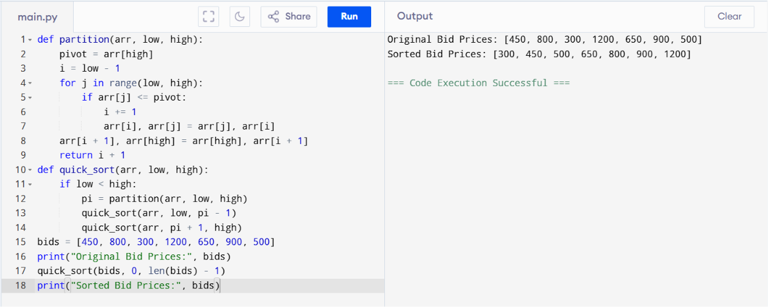
7. Divide and Conquer Principle
Quick Sort follows the Divide and Conquer approach:
- Divide: Select a pivot and partition the array.
- Conquer: Recursively sort the left and right partitions.
- Combine: Since each partition is already sorted, no additional merging is required.
This strategy significantly improves sorting efficiency for large datasets.

8. Pivot Selection Issues
The choice of pivot directly affects Quick Sort's performance.
Good Pivot Selection
- Middle element
- Random element
- Median-of-three
These usually create balanced partitions and improve efficiency.
Poor Pivot Selection
- Always choosing the first or last element on already sorted data.
This creates highly unbalanced partitions and increases execution time.

9. Uneven Data Distribution
When the pivot divides the array unevenly:
- One partition becomes very large.
- The other becomes very small.
- Recursive depth increases.
- Performance degrades to the worst case.

10. Time Complexity Analysis
Case | Time Complexity
Best Case | O(n log n)
Average Case | O(n log n)
Worst Case | O(n²)
Space Complexity
O(log n) (Recursive call stack)

11. Performance Analysis
Best Case
Occurs when the pivot divides the array into two equal halves.
- Balanced recursion
- Faster execution
- Efficient sorting
Average Case
Random input generally produces balanced partitions.
- Excellent practical performance
- Used in many real-world applications
Worst Case
Occurs when the array is already sorted and the first or last element is always chosen as the pivot.
- Highly unbalanced recursion
- Maximum comparisons
- Slow execution

12. Optimizations
To improve Quick Sort performance:
- Use Random Pivot Selection to reduce the chance of worst-case partitions.
- Use Median-of-Three Pivot Selection for better partition balance.
- Switch to Insertion Sort for very small subarrays.
- Apply Tail Recursion Optimization to reduce recursion depth.
These optimizations improve performance and make Quick Sort more reliable for dynamic datasets like online auction systems.

13. Analysis
Quick Sort is highly suitable for an online auction ranking system because it sorts bid prices efficiently using the Divide and Conquer approach. With proper pivot selection, it achieves O(n log n) average performance, making it effective for real-time ranking. However, poor pivot choices can degrade performance to O(n²), so optimization techniques such as random pivot selection and median-of-three are recommended.

14. Conclusion
Quick Sort is an efficient sorting algorithm for ranking auction items by bid price. Its Divide and Conquer strategy enables fast sorting for large datasets. Although the worst-case time complexity is O(n²), proper pivot selection and optimization techniques significantly improve its practical performance, making it suitable for real-time online auction systems.

